A random Data set by OpenNeuro

<https://sccn.ucsd.edu/~arno/fam2data/publicly_available_EEG_data.html>

BCI competition

[Results of the BCI Competition III](http://www.bbci.de/competition/iii/)

Home · Wiki · sb / simbci · GitLab… simulator

[Home · Wiki · sb / simbci · GitLab](https://gitlab.inria.fr/sb/simbci/-/wikis/home)

Brain Electrical Source Analysis: BESA Simulator > Overview

<https://www.besa.de/products/besa-simulator/besa-simulator-overview/>

EEG simulation

<https://cs.brown.edu/people/epavlick/eeg/main.html>

SEREEGA Simulator

<https://github.com/lrkrol/SEREEGA>

meagmohit/EEG-Datasets

<https://github.com/meagmohit/EEG-Datasets>

Methods of EEG Signal Features Extraction Using Linear Analysis in Frequency and Time-Frequency Domains

<https://www.hindawi.com/journals/isrn/2014/730218/>

# A mobile EEG study of auditory oddball processing in the laboratory and real-world conditions

<https://openneuro.org/datasets/ds003620/versions/1.0.1>

MNE- Python: signal analysis software

<https://mne.tools/stable/overview/>

ELAN: another analysis software

<https://www.hindawi.com/journals/cin/2011/158970/>

Open neuro all datasets

<https://openneuro.org/public/datasets>

The EEG dataset used in this research was created and contributed to PhysioNet [19] by the developers of the BCI2000 [20] instrumentation system. The dataset is publically available at <http://www.physionet.org/pn4/eegmmidb/>.

The dataset consists of more than 1500 EEG records, with different durations (one or two minutes per record), obtained from 109 healthy subjects. Subjects were asked to perform different motor/imagery tasks while EEG signals were recorded from 64 electrodes along the surface of the scalp. Each subject performed 14 experimental runs: A one-minute baseline runs (with eyes open) A one-minute baseline runs (with eyes closed) Three two-minute runs of each of the four following tasks: o The left or right side of the screen shows a target. The subject keeps opening and closing the corresponding fist until the target disappears. Then he relaxes. o The left or right side of the screen shows a target. The subject imagines opening and closing the corresponding fist until the target disappears. Then he relaxes. o The top or bottom of the screen. A target appears on either. The subject keeps opening and closing either both fists (in case of a top-target) or both feet (in case of a bottom-target) until the target disappears. Then he relaxes. o The top or bottom of the screen A target appears on either. The subject imagines opening and closing either both fists (in case of a top-target) or both feet (in case of a bottom-target) until the target disappears. Then he relaxes. The 64-channels EEG signals were recorded according to the international 10-20 system (excluding some electrodes) as seen in Fig. 2.

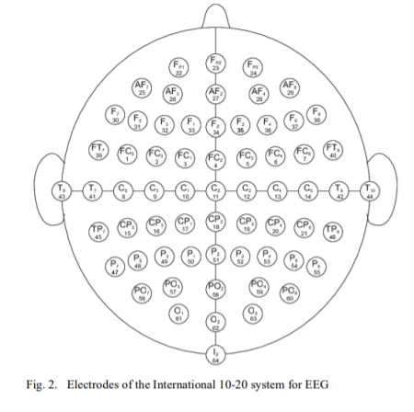

Data sets bnci (BCI based)

<http://bnci-horizon-2020.eu/database/data-sets>

Google Datasets

<https://datasetsearch.research.google.com/search?query=eeg&docid=L2cvMTFuZzZtZ2Jiag%3D%3D>